Introduction to Line Management
Review Document:

What is your new role and why is it so important?
Line manager responsibilities

- Which of these do you actively take responsibility for in your current role or expect to take responsibility?

- Of these, do you need more support to feel confident in your role as line manager? Please provide some details.

Consider this…
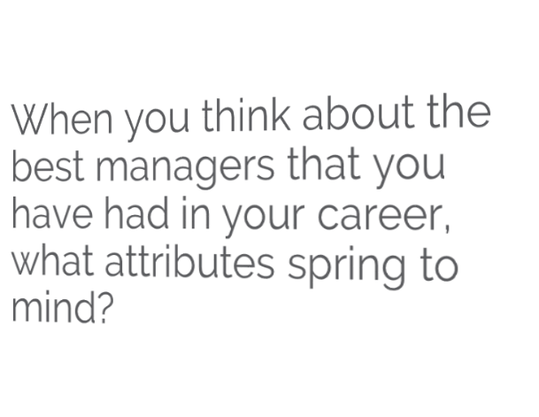

- What attributes does a good line manager have?

What makes a good line manager?
It is a useful exercise to consider, based on feedback that you have received both in and out of work, how you would fare against the following characteristics where 1 = not good and 10 = excellent.
Attribute (Score 1-10)
Personal Attribute | Score
I am personable and approachable.
I listen to people and try to see things from their perspective.
I am aware of my own strengths and the areas where I need to develop.
I can organise myself and other people/resources.
I understand what the organisation needs well enough to translate it into actions and direction for my team.
I set an example in the way in which I react and adapt to changing environments.
I can motivate other people and be positive even on a bad day.
NOTE: As an aspiring manager, you are not expected to score 10 on everything straight away, but to understand where your development areas may lie and be ready to embark on a learning journey.
The what and how of line management
New role and behaviours
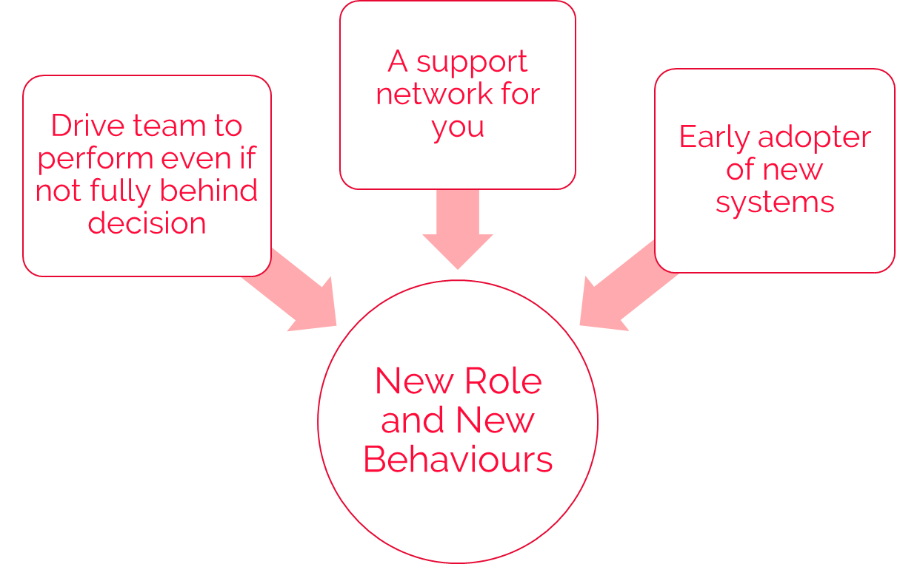
- Are you able to support others during times of change and stay well and healthy yourself?

- Who will you go to provide support in this role?

- How would you handle a situation where you have to follow a direction you’re not 100% happy to do so?

Consider this…

What will you need to stop doing to move into your line manager role and be successful? How you will make this happen?
- What things in your non-managerial job will you have to leave behind?

- How will you make sure this happens?

Your new role
- Why do you want this line manager role?

How to make it happen – 5 focus areas for new managers
Consider this…

As a manager, you have responsibility for how your team feels about their work. What makes you excited about the challenge? What concerns do you have?
- What makes you excited about the challenge?

- What concerns do you have?

